STANDARD FORMAT OF “LEHENGA DESCRIPTION”


For Online Selling Products
Design Name: ZARIYA-C
Product Colours NO.: C2
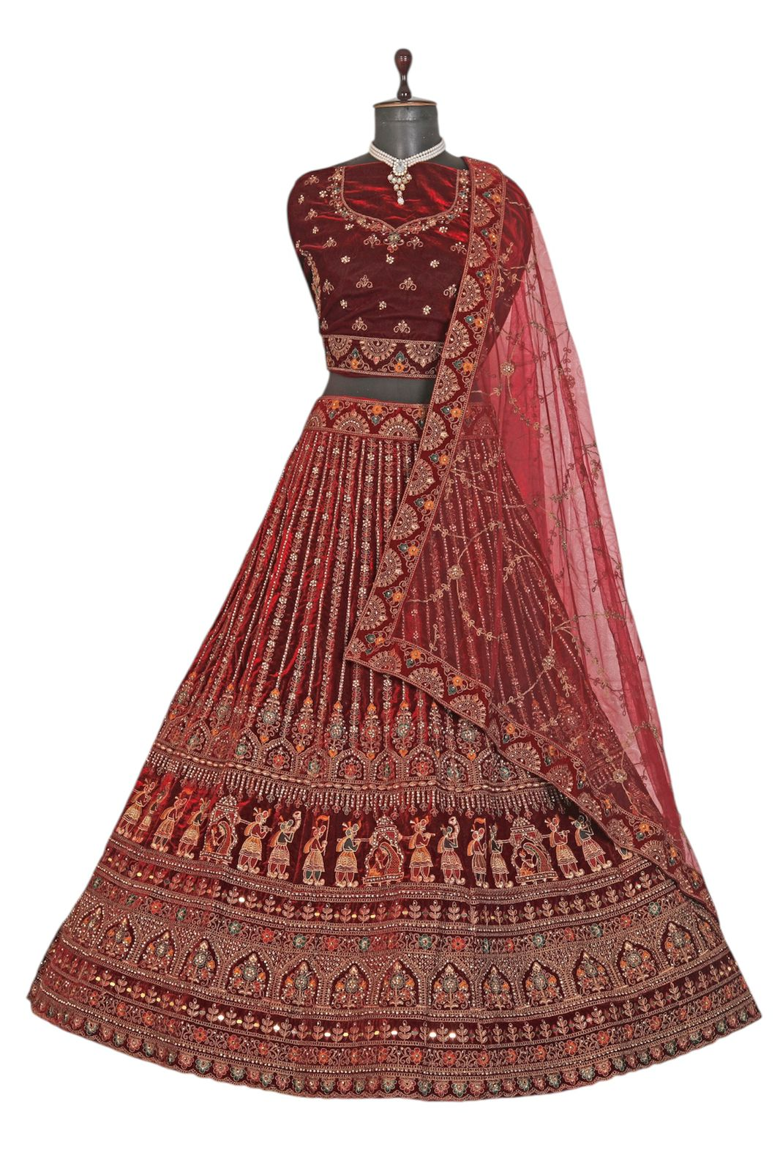
Particulars | Details
Lehenga Fabric | Velvet
Blouse Fabric | Velvet
Dupatta Fabric | Net
Work Type | Heavy Zari & Sequin Embroidery
Colour | Light-Maroon
Pattern | Bridal Designer
Stitching Type | Semi-Stitched (Can be customized up to 44")
Occasion | Wedding, Reception, Engagement & Festive Wear
Fit Type | Regular Fit
Care Instructions | Dry Clean Only
Package Contents | 1 Lehenga, 1 Blouse Piece, 1 Dupatta

KEY HIGHLIGHTS
- Luxurious velvet lehenga and blouse offering a rich and premium look
- Elegant net dupatta enhancing the overall bridal appearance
- Intricate heavy zari and sequin embroidery for a grand festive shine
- Bridal pattern crafted specially for weddings and traditional occasions
- Semi-stitched design for easy size adjustments and perfect fitting
- Comfortable regular fit suitable for long wedding functions
- Comes with matching lehenga, blouse, and dupatta as a complete set
- Combines traditional craftsmanship with a modern, elegant style

